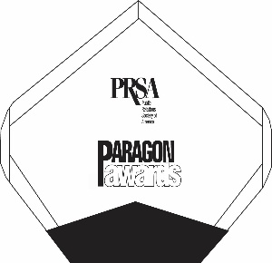
2022 PRSA PARAGON AWARDS – ENTRY FORM
Please submit this form with each entry.
Additional forms are available online at www.PRSAWIS.org.

- Entry Title : ____________________________________________________________________
- Award Category and Number: _____________________________________________________
- Name of Organization: ___________________________________________________________
- Name of Agency (if applicable): ___________________________________________________
- Contact Name: _________________________________________________________________
- Phone: ________________________________________________________________________
- Email: _________________________________________________________________________
Should your entry win, please advise how you would like the award engraved. If character limits are exceeded, the Paragon Committee will determine the content.
- Name of organization or individual (17 character limit): _______________________________
- Name of campaign or client for which award was received: ____________________________
- Please list name of organization or person(s) who you’d like recognized, should your entry win: ____________________________________________________
- Briefly describe your entry. This statement will introduce your entry to judges and be used at the awards program, should it win:

DEADLINE: Entries and payments need to be received no later than 5 p.m. CDT on Friday, March 18, 2022. Entries and payments received after the deadline will not be considered.
SUBMIT TO: Joette Richards at prsasewi@gmail.com.
CONTACT INFORMATION FOR QUESTIONS
Questions regarding the entry process or entry categories may be directed to PRSA Administrator & Entry Coordinator Joette Richards (prsasewi@gmail.com) or Christine Dunbeck, PRSA Board Member and Immediate Past-President (christinedunbeck@gmail.com).

